Rustam Irani Naorooz Driver was born on July 2, 1897 in Yazd, Persia. (Later, when living in the USA, he called himself Naorooz Rustam, thereby reversing his first and last names and leaving Driver out) His parents were Freiny nee Irani and Naorooz Darius Driver and he was the oldest of four sons, the other three being Homi, Keki and Faredoon. His paternal grandfather was Darius. (born 1847 or earlier) His family was of the Zoroastrian faith. Naorooz is an interesting name as per Wikipedia:

Nowruz means "new day” and is the name of the Iranian New Year, also known as the Persian New Year, which is celebrated worldwide by the Iranians, along with some other ethno-linguistic groups, as the beginning of the New Year. Nowruz is also the holiest the of the Zoroastrian holidays and "It seems a reasonable surmise that Nowruz, with deep doctrinal significance, was founded by Zoroaster himself.”

Originally, as mentioned, Rustam was from Yazd, Persia. Per Wikipedia:

(note: Yazd means “God”)

Yazd's heritage as a center of Zoroastrianism is important. There is a Tower of Silence on the outskirts, and the city itself has an ateshkadeh (fire temple) which holds a fire that has been kept alight continuously since 470 AD.

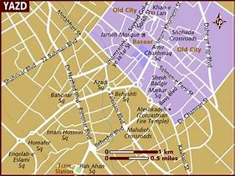

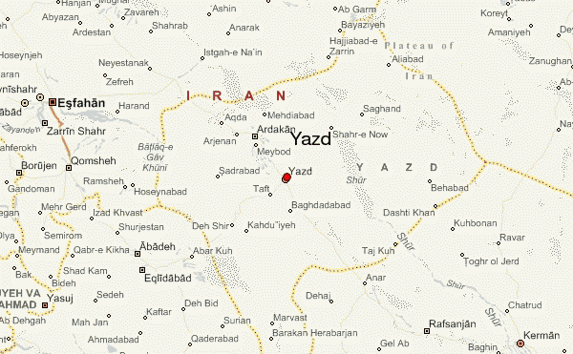

His family had probably been in Persia for many centuries but by the 19th century, Muslim persecution of Zoroastrians had become very intense, and thus, in the early 1900’s Rustam and his family decided to escape to India to Bombay, where they already had relatives. (Note: Meher Baba’s father, Sheriar Irani lived until age 12 in a village near Yazd. (1853-1865). He was Zoroasterian).

His family’s arduous journey ( he actually came with a band of children) to escape from Persia and come to India in the early 1900’s was described in a (1942?) interview in Tenn. by the local newspaper. For his whole lifetime, Naorooz felt he was Persian rather than Indian, which was quite different than some of his younger siblings who were born in India (including Padri).

Although the term 'Irani' is first attested during the Mughal era, most Iranis are descended from immigrants who left Iran and migrated to the Indian subcontinent during the late 19th and early 20th centuries. At the time, Iran was ruled by the Qajars and religious persecution of Zoroastrians was widespread. The descendants of those immigrants remain culturally and linguistically closer to the Zoroastrians of Iran, in particular to the Zoroastrians of Yazd and Kerman, than to Parsis in India or Pakistan. Consequently, many Iranis still speak the Dari dialect of the Zoroastrians of those provinces. https://ipfs.io/ipfs/QmXoypizjW3WknFiJnKLwHCnL72vedxjQkDDP1mXWo6uco/wiki/Irani_(India).html

The family moved to Bombay where Rustam’s brother Faredoon ( later named Padri by Meher Baba) was born in 1903. From Wikipedia:

Faredoon Nawrosjee Driver, better known as Padri, (November 27, 1903 - March 13, 1982) was born in Bombay, India and was one of Meher Baba's close mandali (devoted disciples). He lived with and served Meher Baba from 1922 until Meher Baba's death in 1969, beginning his stay with Baba in Baba's first ashram, Manzil-e-Meem. Later, after moving his ashram to Ahmednagar district, Meher Baba called Padri one of the four "pillars" of Meherabad. (Meherabad was Meher Baba's second ashram and is today the site of Baba's samadhi shrine). Padri, who was originally a garage mechanic,^{[1]} later became a doctor of homeopathy treating local villagers near Meherabad.^{[2]}
Meher Baba nicknamed Faredoon "Padri" because of his lanky, priestlike stature. Padri emphasized obedience to the master and had little patience for ostentatious sentimentality, famously quoted as saying, "Love is for the saints and the masts, not for the likes of us!"^{[3]}
Padri's remains are buried at lower Meherabad.

A short time after Faredoon’s birth, the family, including 4 sons, Rustam, Homi, Faredoon and Keki, moved to Poona very near where Babajan, the Perfect Master, sat under a neem tree on Malcolm Tank Rd.(now Jaan Mohammed St) in Char Bawdi. Their house was in visual distance from where Babajan sat. Freiny Masi, the mother, became enamored with Babajan and visited her every day. In this way, Rustam also came into contact with the perfect master who later would initiate Baba into universal consciousness. Babajan’s seat under a neem tree was 700 meters south of Baba’s house (when he was called Merwan).

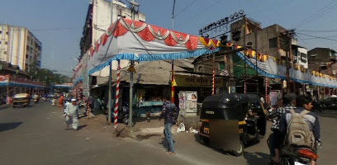

Hazrat Babajan’s Chowk, Jaan Mohammed St, Pune

Rustam also had a brother Homi:

The second brother was named Homi (Keki was the other brother) (who must have been the one in the army in Palestine during world war I.) Homi ran the Buick-Opel dealership in Poona. Padri last saw him in 1954 when Padri was returning from the Satara meeting where Baba dropped the alphabet board. Homi had a daughter named Meheru who married a muslim man name Rafat.

(David Nordeen, 2013)

Freiny Masi’s contact with Babajan:

(https://www.independentphilosophy.net/Hazrat_Babajan.html)

In about 1905, the Irani Zoroastrian woman Freiny Masi (Driver) became a devotee. She was the sister of Daulat(mai) Irani, who was the mother of Mehera J. Irani (1907-1989); the latter two women also became involved with Babajan, but to a lesser extent. Freiny Masi had the repute of being "one of Poona's beauties," though images of her are elusive. Her marriage to a Parsi (Nauroj Driver) was not successful. She separated from her husband and chose to live alone in a small room opposite Babajan's "seat" under the neem tree in Char Bawdi. She would go back home for meals, "but otherwise spent the whole day with Babajan, or resting in her room" (Fenster 2003, p. 59). She could actually see Babajan from her window.

Freiny Masi became an intimate of the faqir until the latter's death. She would render personal service to Babajan in such matters as tea-drinking. She was present when Babajan decided one day to visit the Bund Gardens, some distance away on the other side of the city. Instead of taking a tonga or horse cab for this purpose, the elderly faqir walked. Freiny Masi and others tried to persuade her that a tonga would be advisable, but Babajan expressed annoyance at this prospect. Despite her age, Babajan walked so fast that her companions found it difficult to keep pace. Freiny Masi complained that her own feet would hurt over the distance involved, and urged that she and Babajan should take a tonga. The faqir only agreed because her intimate devotee was making the request. This appears to have been one of Babajan's early visits to the Bund Gardens, which she afterwards frequented.

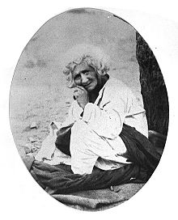

Babajan under the neem tree

https://en.wikipedia.org/wiki/Hazrat_Babajan

Freiny Masi’s husband, Naorooz, had been a locomotive drive in Persia and possibly in India too. He was not “spiritual” as was Freiny and also the couple had marital problems, eventually causing Naorooz to leave.

Rustam fought in WWl as did his brother Homi who fought in Palestine The end of WWl in late 1918 was near to the time when he decided he wanted to go to the USA, supposedly to get into movies. He met Merwan before he was called Meher Baba and when He was still “coming down” to the gross plane.

Babajan, as mentioned, was his key connection (as distinct from his younger brother Padri, who was one of the early Mandali). She was the one who recommended he move to America.

He started out the voyage with 2 friends enroute to NYC in June, 1920 where he arrived on his 23rd bday on July 2, 1920 on the USS Olympia from Marseilles.

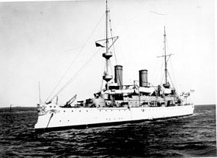

USS Olympia

https://en.wikipedia.org/wiki/USS_Olympia (C-6)

He came to America by ship at a time when it took about 2 weeks to get from India to the USA. When he and his 2 companions, Sohrab Rustam and Khodadad Rustam, arrived in New York, they decided to stay there while they decided what to do. Sohrab was 20 years old and from Bombay. His father was an engineer. Khodadad, 25, was born in Yazd, the same city Naorooz was born in. This seems to indicate they were cousins.

Naorooz became a subway conductor, presumably to make ends meet. At some point he realized his dream of becoming a movie star was not going to work, so he turned to his practical side and decided to become an engineer. He may have had some background in this field in his education in India.

Remarkably, he was able to receive a scholarship from the Govt of Persia for his education. This was quite a paradox as Persia was the very country he and his family had to escape from when he was a young child. How he was able to get that scholarship must have quite a story!!!

He applied and was accepted to the Colorado School of Mines, an engineering university in Golden, CO just outside of Denver. He started in 1923 (need to do some research to confirm), in the “Wild West”.

Baba’s will was subtly apparent in Naorooz’s choice of schools as the motto of the university was Nil sine numine in Latin, meaning “Nothing is without God’s will.”

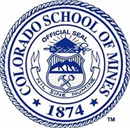

History of the Colorado School of Mines

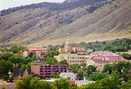

In 1874 the School of Mines, supported by the territorial government (Colorado became a state in 1876) since efforts began in 1870, was acquired by the territory and has been a state institution since 1876 when Colorado attained statehood. Tuition was originally free to residents of Colorado.[]

Mines became the first school of its kind in the world to own and operate its own experimental mine, designed for practical teaching of the students.

The first building on the current site of the school was built in 1880.The next building to be added to the campus was Engineering Hall, built in 1894.

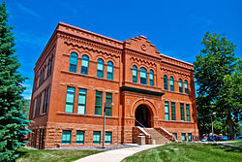
Engineering School built 1894
https://en.wikipedia.org/wiki/Colorado_School_of_Mines#History

In the 1920s, departments formed in geology, petroleum engineering and geophysics. Naorooz became a geological civil engineer, and unsurprisingly, his first job upon graduation was in the mining country of West Virginia (note: by coincidence, my mother was born in the same area in 1929).

During these years at the university, he apparently met a Catholic priest, Joseph Nathan Oldenburg, who worked out of the Archdiocese in Denver. Rev. Oldenburg became extremely enamored with Meher Baba, who said He was the Avatar of the age, and began a long time correspondence with Him.

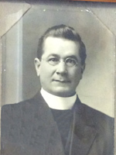
Rev. Oldenburg, circa 1915
Fruita, CO

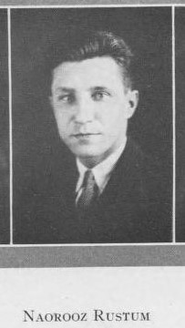

Senior Class picture in “The Prospector”
CO School of Mines, 1927

From Lord Meher:
Padri's (and Rusi’s) mother Freiny Masi met Baba at Meherabad on Sunday, 7 August 1927 Baba asked Freiny Masi about her son (Padri's elder brother) Rusi, who had been one of Baba's classmates and who was then in America.
Naorooz moved to WV the same year of his graduation and the same year he declared his intention to become an American citizen. He got a job as a civil engineer in Gauley Bridge and met his wife to be, Gladys Daughtery, who lived in a nearby town.

The couple married on August 2 1930 and Naorooz converted to Christianity at the request of this wife.
Name: | Naorooz Rustam
Age (Expanded): | 33 years
Birth Year): | July 2, 1897
Spouse's Name: | Gladys M. Dougherty
Spouse's Age (Expanded): | 20 years
Spouse's Birth Year (Estimated): | July 10, 1910
Event Type: | Marriage ( in a church)
Event Date: | 02 Aug 1930
Event Place: | Gauley Bridge, Fayette, West Virg
Father's Name: | Naorooz Driver
Mother's Name: | Freni Masi Irani
Spouse's Father's Name: | J.A.
Spouse's Mother's Name: | E.L.

He also became a naturalized US citizen the same year. According to his son Fredrick, Naorooz always tried to fit into American society and did not like to think of himself as a foreigner.

See next page

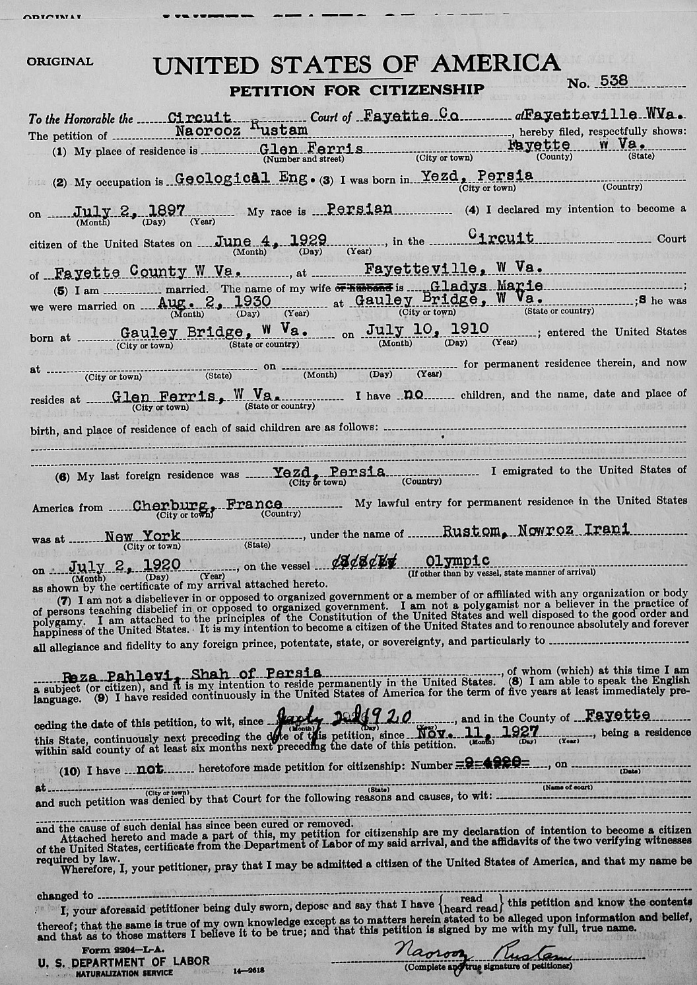

It is interesting that Naorooz said he was renouncing allegiance to Reza Pahlavi, Shah of Persia, as Reza Pahlavi did not ascend to power until 1925. Naorooz was referring to the current Shah at the time of his naturalization rather than the leader who was in power about 1903 when he left Persia or in 1920 when he left India (but still considered himself Persian).

In 1903, Mozzafar-al-Din Shah, leader from 1896 to 1907, of the Qatar Dynasty was in power and his cruel policies toward Zoroasterians catalyzed the Driver family to emigrate to India.

In 1920, Ahmad Shāh Qājār, (21 January 1898 to 21 February 1930) was Shah of Persia (Iran) and ruled from 16 July 1909, to 15 December 1925. He was the last ruling member of the Qajar dynasty. (per Wikipedia).

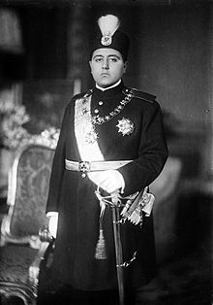

Ahmad Shah Qatar

The couple had their first child, Frederick, on July 4, 1934. Their second child, Nancy, was born on Jan. 12, 1939.

About Gauley Bridge: (per Wikipedia)

Gauley Bridge is a town in Fayette County, West Virginia, United States. The population was 614 at the 2010 census. The Kanawha River is formed at Gauley Bridge by the confluence of the New and Gauley Rivers. Two miles to the southeast of Gauley Bridge, in Glen Ferris, West Virginia, is Kanawha Falls, a popular stopping point on Midland Trail Scenic Highway. It is 38 miles southeast of Charleston.

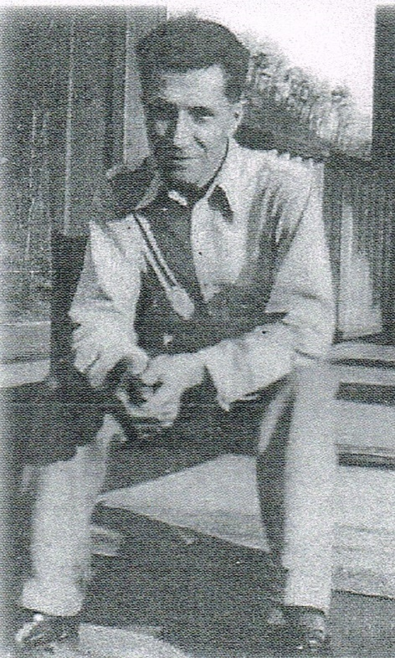

Naorooz in 1935 in WV

In 1940, the family was living in White Sulphur Springs, WV.
In the early 1940’s,the family moved to Knoxville, Tennessee where Naorooz worked for the TVA, evidently for the War effort.

The TVA

TVA was created—in large part—to manage flooding on the Tennessee River. ... Tennessee Valley Authority 400 West Summit Hill Drive Knoxville TN
Naorooz lived at 2332 Fifth Ave in 1948. But was there by 1942. He may have been brought in to help the war effort. He lived only 2 miles from work.

The Tennessee Valley Authority is a federally owned corporation in the United States created by congressional charter on May 18, 1933, to provide navigation, flood control, electricity generation, fertilizer manufacturing, and economic development to the Tennessee Valley, a region particularly affected by the Great Depression. The enterprise was a result of the efforts of Senator George W. Norris of Nebraska. TVA was envisioned not only as a provider, but also as a regional economic development agency that would use federal experts and electricity to more quickly modernize the region's economy and society

TVA's service area covers most of Tennessee, portions of Alabama, Mississippi, and Kentucky, and small slices of Georgia, North Carolina, and Virginia. It was the first large regional planning agency of the federal government and remains the largest. Under the leadership of David Lilienthal ("Mr. TVA"), the TVA became a model for America's efforts to help modernize agrarian societies in the developing world.^{[1]}

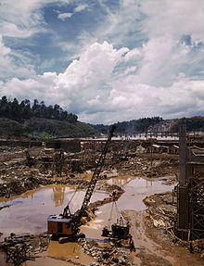
The Douglas Dam early in its construction in 1942.
During World War II, the U.S. needed greater aluminum supplies to build airplanes. Aluminum plants required huge amounts of electricity. To provide the power, TVA engaged in one of the largest hydropower construction programs ever undertaken in the U.S. By early in 1942, when the effort reached its peak, 12 hydroelectric plants and one steam plant were under construction at the same time, and design and construction employment reached a total of 28,000. The largest project of this period was the Fontana Dam. After negotiations led by Vice-President Harry Truman ("I want aluminum. I don't care if I get it from Alcoa or Al Capone."), TVA purchased the land from Nantahala Power and Light, a wholly owned subsidiary of Alcoa, and built Fontana Dam.

The government originally intended the electricity generated from Fontana to be used by Alcoa factories. By the time the dam generated power in early 1945, the electricity was directed to another purpose in addition to aluminum manufacturing, as TVA also provided much of the electricity needed for uranium enrichment at Oak Ridge, Tennessee, as required for the Manhattan Project and the making of the atomic bomb.

As odd as it may sound, it appears that Naorooz was part of the creation of the atomic bomb! This can sound “bad”,but if Baba ordained it, it probably was a blessing.

Naarooz’s son Frederick said his father never talked about Meher Baba and was self-conscious about his Eastern accent, especially in places like West Virginia. The newspaper in Knoxville interviewed him in 1942 and wrote a great article about his life. In 1948 the family was living at 2309 E Fifth St, Knoxville. (per Knoxville newspaper).

Nancy got married in Elizabeth City, NC in 1959 to Willam Horace Ingram of PA. Both of them were age 20. This was her first of three or four marriages.

Naorooz was in Finn Castle VA in 1959 while his wife and kids were in Wash DC. It seems to imply he had already separated from the family. “Fincastle is a town in Botetourt County, Virginia. The population was 353 at the 2010 census. It is the county seat of Botetourt County.^{[3]}Fincastle is 20 miles N. of Roanoke.”

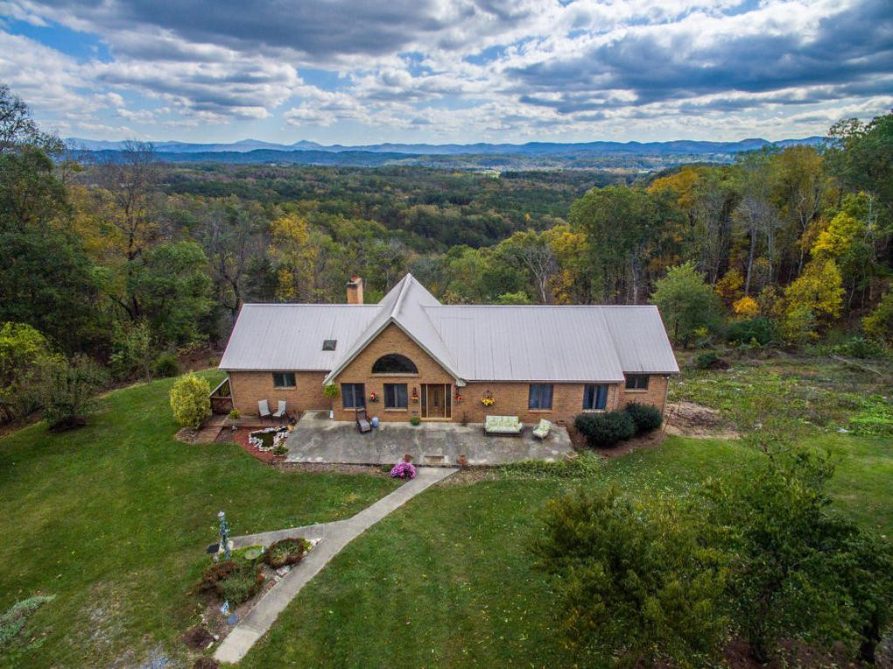

In Fincastle, VA

It is not known yet when Naorooz separated from his family, but by 1967 he was married to Mary Allen, b. 1905, in Little Rock, Ark. Her parents were Samuel Allen and Minnie Alyosus. (per 1967 Soc. Sec application by Mary).

At some point, Naorooz ,moved to Pharr, Texas where he co-founded a Unity church, called Unity of the Valley.. Interesting choice as Unity is perhaps the closest of the Christian churches to a “Baba-like” feel.

Per Wikipedia:

Pharr is a city in Hidalgo County, Texas, United States. In 2016 the estimated population was 77,320.^{[4]} Pharr is connected by bridge to the Mexican city of Reynosa, Tamaulipas.

First wife in 1920 Census
Name | Gladys Dougherty
Event Type | Census
Event Date | 1920
Event Place | Gauley Bridge, Fayette, West Virginia, United States , this where Naorooz went in 1927
Gender | Female
Age | 9
Birth Year (Estimated) | July 10, 1910
Birthplace | West Virginia
Father's Birthplace | James, age 38, born Germany, coal miner
Mother's Birthplace | Ella, age 31, born WV

2nd wife Mary Allen Rustam

United States Social Security Death Index
Age | 91
Given Name | Mary (maiden name Allen)
Surname | Rustam – second wife of Naorooz
Birth Date | 20 Jul 1905
State | Texas (this may mean she was with Naorooz when he moved to Texas).
Event Date | 16 Feb 1996
Naorooz was a member of The Tau Beta Pi Association (commonly Tau Beta Pi, ΤΒΠ, or TBP) is the oldest engineering honor society and the second oldest collegiate honor society in the United States.
It honors engineering students who have shown a history of academic achievement as well as a commitment to personal and professional integrity.
Specifically, the association was founded "to mark in a fitting manner those who have conferred honor upon their Alma Mater by distinguished scholarship and exemplary character as students in engineering, or by their attainments as alumni in the field of engineering, and to foster a spirit of liberal culture in engineering colleges".
]

Searcy (/ˈsɜːrsi/ SUR-see) is the largest city and county seat seat^{[3]} of White County, Arkansas, United States. According to 2014 Census Bureau estimates, the population of the city is 23,768.^{[4]} It is the principal city of the Searcy, AR Micropolitan Statistical Area which encompasses all of White County. The city takes its name from Richard Searcy, a judge for the Superior Court of the Arkansas Territory. A college town, Searcy is the home of Harding University.

This is where Naorooz and his wife lived in
the 1980’s. Just north of Little Rock where Mary was born.

Rustam Naorooz Driver’s mother was Freiny Masi Irani (born in 1870’s) and his father was a locomotive engineer (in Persia). After moving to Poona, Freiny became an extremely devoted “disciple” of Babajan and they lived within viewing distance of the old woman. Freiny later became a devotee (very early) of Meher Baba, but probably knew him before he became Avatar.

Rusi’s brother was Padri, one of Meher Baba’s closest, earliest and long-term mandali. Rusi’s first cousin was Mehera!! This adds up to a powerful, intimate spiritual heritage, close to the Ancient One. Also, he and Merwan were in school together, although separated by 3 years in age. In either elementary, middle school or high school. In my opinion, although Rusi did not profess interest in Baba for the majority of time in America, Baba’s hand in his destiny was very profound. He certainly was the only one so connected many ways to the Avatar to spend such a long time in America.

He may have separated from Gladys at some point when she lived in DC and he lived in Finn Castle, VA in 1959. Not known when he married Mary Allen, his second wife, but it was by 1967.

Here is a subtle coincidence. Baba named Faredoon “Padri”, meaning “priest” and then Naorooz met an actual priest in CO. only about two years later.
. Naorooz’s children:
Fredrick, born July 4, 1934 in WV, and Nancy Claire, b. Jan. 12, 1939. Apparently Fredrick never married and lived many years living in Washington DC, where He spent 28 years indexing technical reports for the Department of Defense. “He definitely prefers writing fiction to figuring out what the heck those darn technical writers are going on about. In 1995, he began to write science fiction stories.”
Nancy married either three or four times and had at least two children. Her first marriage was in 1959 when both she and her groom were 20 years old. It does not appear that Naorooz and Gladys attended the wedding. They also may have separated by then. Her husband was William Horace Ingram of Pennsylvania and they were married in Elizabeth City, NC. Naorooz was living in Finn Castle, VA at the time of the marriage and Gladys was living in Wash. DC.
Nancy and William had at least one child, a daughter, born in 1964. Probably Susan.
She divorced her first husband and married again. Do not know the name of second husband yet.

Her third marriage was July 7, 1973 in Arlington VA to Michael Herman Lester, b. 10-21-50, age 22. His father was Herman D. Lester and mother was Marg. E. Bentley. She and hubby lived at 7400 Austin St, Annandale, Va. The ceremony was at a Unitarian Univ. Church. Nancy was 34 at the time of this marriage.

After all her marriages which ended by the 1980’s, Nancy changed her last name back to Rustam, her maiden name. She lived in Takoma Park, MD for awhile working for an airlines.

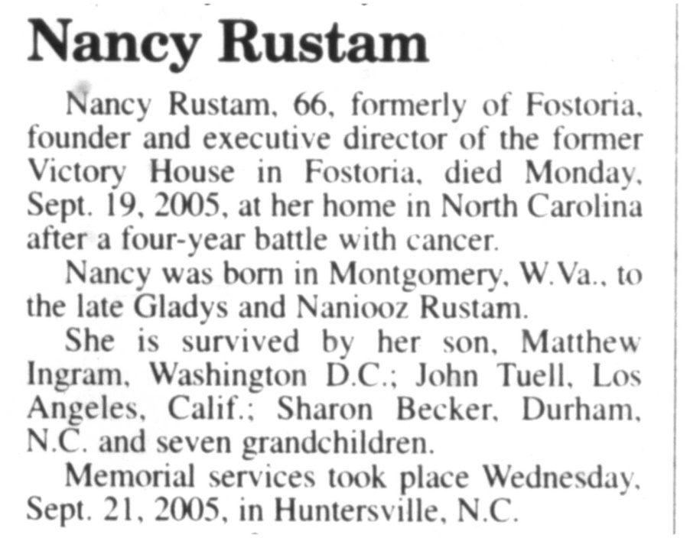

Nancy’s obit, Tiffin Ohio

Advertiser Tribune, 9-23-2005

Naorooz’s Second Marriage

Naorooz apparently got a divorce from his first wife Gladys, possibly in 1950’s. He then married again to Mary Allen, b. July 20, 1905, in Little Rock Arkansas. Have not pinned down yet how they met or where they got married. The did stay together until Naarooz’s death in 1989.

