This January, a request was received from the Trust in India for biographical information on certain British people whose names are inscribed on Baba’s Memorial Tower in Meherabad. These particular British people are not generally known or remembered nowadays except by Baba. Sarah McNeill was asked to facilitate and a request went out for further help. Shelagh Rowling has been sleuthing - on line, elsewhere and at the British Library, London. The initial research has generated a further project to record everyone who met Baba during His visits to Britain from the 1930s - some hundreds of souls.
Shelagh writes . . .

Let me introduce you.…

Hundreds of people met Meher Baba on His seven visits to Britain in the 1930s. They came from all corners of the UK, a few from across Europe or over the Atlantic. Like Baba lovers today, they stemmed from all walks of life each having their own ‘Baba story’ - but they shared the destiny of actually meeting the Avatar. On the whole we know little or nothing about most of these people except that Baba drew them to Him.
The request for short biographies on some little-known British Baba lovers whose names are inscribed on the Memorial Tower in Meherabad, started the ball rolling to glean information, initially from letters in the Trust archive, so as to assemble a more complete picture of early UK Baba lovers. It is very much a work in progress, by no means definitive, but already there are some people I would like you to meet…

Perhaps you know of Rosamund Butler, Countess of Carrick (in the west of Scotland) a seeker who read of Baba in The Occult Review* and in The Times of India. She took the opportunity to write to Him in 1930 while visiting family in Kashmir, describing herself as “an earnest student and seeker” who had been “seeking the knowledge of God all her life”. She pleaded for a short interview with ‘His Holiness’ and added it was “not out of any idle curiosity.” Baba replied that He was glad with her “desire and longing for communion and realisation with the Divine Self.” She journeyed across India by train alone to reach Baba in Nasik and stayed overnight in the ashram. The following day she returned to London.

*The Occult Review was a British publication that Meredith Starr wrote for frequently. In 1929 after his 6 months with Baba in India he wrote: In Praise of the Beloved, and Shri Sadguru Meher Baba (a letter). He continued to write Baba articles through the1930s as did other Baba followers.

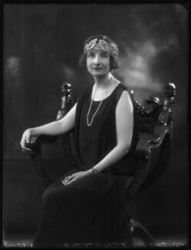 Rosamund Butler (National Portrait Gallery)

Also from Scotland was Christina McNaughton (1904-1941) - aka Christine or Tina - who was originally from the Highlands, her father Duffie, being a lockkeeper on Kyltra lock, Fort Augustus.

She first met Baba from 7-14th December, 1932 when she was working as a waitress at the Knightsbridge Hotel, London. She delivered the room service to Baba’s party and saw to their needs, making many visits to the suite each day.

Baba encouraged the Western women disciples to bring her up there! Baba commented, “She is a very spiritual type, a very good soul”, and He asked Kitty Davy to arrange for Christina to come to India with her the following year, 1933.

For this lengthy trip Christina would have to give up her job, during the Depression, and travel to India after a Master she knew practically nothing of. In her letters to Baba Kitty says she will be all ‘diplomacy and tact’ in approaching Christina. She would propose a world tour, with Christina as her companion. They, with others in the party, would be Baba’s guests in India and would visit family across the world before hearing Baba speak in Hollywood. Kitty gradually dropped hints and introduced the idea, “The next step”, Kitty wrote, “is for her to love me and Baba this is where you can help isn’t it…” Christina was simply delighted to go and preparations started immediately.

The group of Westerners sailed to Bombay amidst unwanted press coverage. In India they met with the women mandali before travelling north with Baba to Agra and Kashmir, staying on houseboats in Srinagar. On this trip Baba took them to Harvan and indicated Mt Harvan where He said Christ’s body had been buried. As it happened Baba’s plans changed and the six month stay with Him in India turned into just three weeks, with the party then returning to Europe.
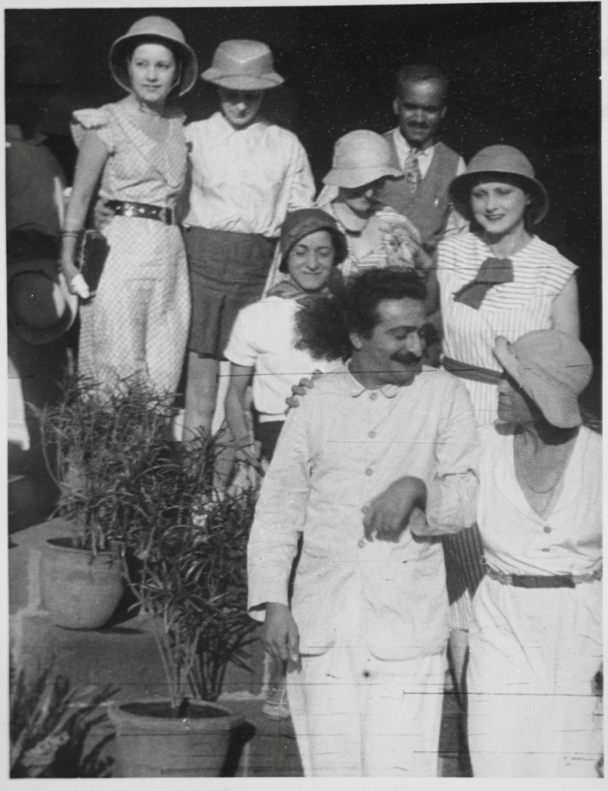
Back in London Christina spent her weekends with her fellow travellers from India as Baba had directed them to live together for a few months. Ten of them shared a house with one bathroom in Ealing.

Christina McNaughton, Minta de Leon, Delia de Leon, Margaret Craske, Dr. Abdul Ghani, Vivienne Giesen, Baba, Mabel Ryan

All of Christina’s letters to Baba show how she longed to be with Him again. She eventually got to see Him in 1936. The following year, as one of Baba’s ‘close ones’, Christina was invited to stay at the ashram in Nasik. In the end Baba’s plans changed, and He travelled to the West where He stayed a month in Cannes. There, Christina visited Him for nine days. She corresponded with Baba until in 1941 she was killed by a direct hit during the London Blitz to 144, Sussex Gardens.

You must meet Herbert Stone (1878-1961), a blind organist, piano tuner and repairer in Bradford, Yorkshire. I understand he and his disabled wife Clara, an ex Worsted millworker, met Baba in 1931. Baba said that Herbert would see in November 1932 - nothing physical came of this however, the date of his healing being delayed until Baba broke His Silence. Herbert is mentioned in letters to Baba and he sent greetings-telegrams to Baba with other devotees from 1934 to 1942. (Later records are not available yet.)

Will Backett had a Baba publication transcribed into Braille for Herbert in 1935. In 1936 Baba sent His love to Herbert and his wife in a letter to Will Backett. Clara is recorded as buying a Baba publication from the Circle Editorial Committee office, 50 Charing Cross Road, London in 1937. Little else is known at present.

Another Yorkshire connection is in Ida Polli who was born in Italy in 1878 and moved to near Harrogate after marrying an Italian Yorkshireman. There they had a daughter. We know that by 1931 Ida was a widow living in London and managing an antique shop in Seven Dials, Covent Garden, which is at the convergence of several streets in the West End theatre quarter.

One morning in her shop she had a vision of what she took to be the face of Christ. The image had tears in his eyes. Taken aback she put her hands over her face and turned away towards the window. When she removed her hands she saw the person of her vision out the window. It was Meher Baba walking on the other side of the road with His Eastern disciples on either side of Him.

After this contact it is not clear how Ida discovered Baba’s identity or indeed when - perhaps through the newspaper reports of Baba’s visit, the Pathe’ newsreel or various magazine articles - but it happened that her home in Holborn was only about 200 metres or so from Dyott Street where Margaret Craske, Mabel Ryan and others shared a house in the early 1930s.

She may very well have met Baba at that time. Records however do show that along with other early Baba lovers in London she sent Baba a birthday greeting telegram in 1942. We know that Ida had Baba’s Darshan on 14th July 1956 at the Rubens Hotel, London. She passed away three years later.

Robert West of The Parsonage, Wilmington, nr Honiton in Devon experienced Baba in a dream where he was told that Baba was ‘the Christ’. He then went down to the beach near East Challacombe where he met Baba. It is not confirmed if this was September 1931 or April 1932.

Meet Ann Powell (1889-1965) from Aberkenfig, originally a mining community, in Glamorgan. She had been exploring Theosophy and seeking when she heard of Baba from Meredith Starr. She was part of the welcoming party for Baba in 1931 when He stayed at East Challacombe retreat in Devon. Of her meeting Baba at that time she wrote how Baba was in the garden playing quoits and how He left the game to sit on a garden seat. He beckoned her to sit with Him. She had been leaning on the front doorpost for support because.. “The whole burden of my past seemed to be upon me…(Baba) placed his hand in mine…the burden was lifted and my Real Self was revealed to me.” Baba said of her: “She will be most sincere to me.” He called her ‘Welsh Ann’.

She returned to East Challacombe in 1932 to prepare the house and to spend time with Baba who was visiting once more. She then became part of the early Baba family in London and was able to see Him there in December 1932. At Baba’s request she shared a house with other women Baba lovers at 7, Dyott Street and acted as housekeeper. Baba visited a number of times and once when a large gathering was crammed in, He called her from the background of the room where she had been hovering after having done all the catering. He sat her down beside Him and fed her grapes.

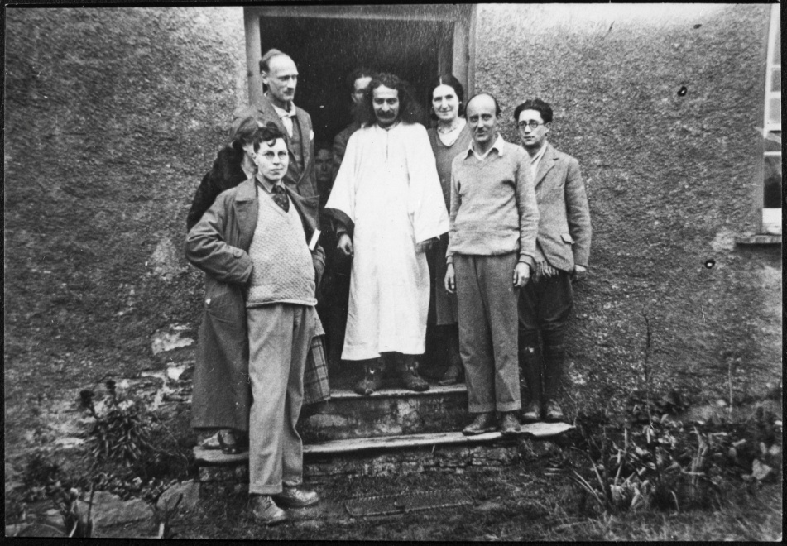
Another brief opportunity to be with Baba again came in 1936. Throughout this time she wrote to Baba with letters of longing.

?, Margaret Starr (half hidden on right), Kenneth Ross Tom Sharpley (behind Baba), Baba, “Welsh Ann” Powell, Meredith Starr, Dick Ince

Ann was a family person, one of ten children, and she would return to Wales to visit and nurse family. Thus she divided her time between Wales and London always keeping in touch with Baba. On 14th July 1956 she had Baba’s Darshan at the Rubens Hotel in London.

May I introduce you to Norman Franklin (1905-1964) who stemmed from Herefordshire but lived in London. The son of a corn merchant, he became a celebrated musician and pianist. He had his Proms debut in 1924, aged 19, playing JS Bach Concerto for 3 keyboards in D minor BWV1063. He often worked with 20th century composers and accompanied singers and ballet dancers. He also worked for BBC radio for over 30 years. He met Baba repeatedly from the early 1930s and was part of the early Baba family in London where he knew Dr Donkin and attended gatherings. He played the piano to Baba in 1932 in London and he wrote that it was “the happiest happening in my life.” His letters to Baba are an outpouring of love and longing. In October 1933 he wrote, “There is a beauty & truth in your presence that is infinity…” and “…this letter is only to say I love you.”
A week later he wrote, “…how can I thank you for letting me know you.” He last saw Baba in 1956 at the Rubens Hotel in London.

Lena Rebecca Harris (1880-1967) was from Peckham, London and a professional nursing sister for over 30 years. She probably met Baba in the 1930s. We know she recognised Him as ‘the Christ’. She too was part of the Baba family in London, sending Baba a birthday telegram in 1942. Lena also wrote to Baba, and in 1944 a covering letter to the mandali starts: “Dear Brother in Christ”. With Baba working throughout India it continues, “…we feel the Christ though we do not see or hear (from Him) from year to year…” and finishes: “Yours in His Service. as sons and daughters of our Father-Mother God.” Lena lived mainly in north London. She died in a care home in Rochford, Essex.

